Project Plan

NSW Traffic Penalty Data Analyser

Assignment Part A: 2810-ICT

Software Technologies.

Thomas Chapman -s5251549

Table of Contents

1.0 Introduction 3

1.1 Problem Background 3

1.2 Scope 3

1.3 Document contents 3

2.0 Work Breakdown Structure 4

3.0 Activity Definition & Estimation 5

4.0 Gantt Chart 6

# Introduction

## Background

NSW is one of the busy states in Australia when it comes to traffic and cars on the road. NSW has approximately 6 million cars on the road. In a state that has highly populate suburbs with very busy roads. Collecting data and being able to compute traffic in NSW is something that will require a lot of work if a person were to undertake this task. Therefore, software and code allow the government to track data and information and display that in a way where they can understand and make changes.

With fixed speed cameras and mobile phone detection cameras being present almost on every major road the number of fines each day has increased dramatically. NSW report $1 billion worth of fines which is an absurd amount of information that would have been processed by some sort of system. This data is what allows the government to see where the most traffic related incidents are and where they should be focusing their resources.

## Scope

The objective of this project is to research and create a system where data from the NSW traffic penalties can be easily displayed to those working in the police / law enforcement department. Being able to interpret and reproduce data in a simple yet effective manner will be a huge improvement for visual understanding of the data they need. This will allow for those who are working for the NSW traffic department or main roads to understand trends and information more easily. It is important to understand the requirements for the given task and any costs or time limits that may be in place. The NSW government will allocate what is necessary for the given project and the progress will be tracked via the use of WBS (work breakdown structure) and the Gantt Chart.

## Document contents

This document will contain 4 major sections, Part A being the initial planning of the document, background information, problem at hand and scope. Part B will contain the plan for the design and how the progress of the project will continue through each stage. Part C will include detailed explanations of each of the planned steps and directly use the WBS. Part D is the final display of all the developed parts and a visual representation of the WBS, Gantt and the steps needed to complete.

# Work Breakdown Structure

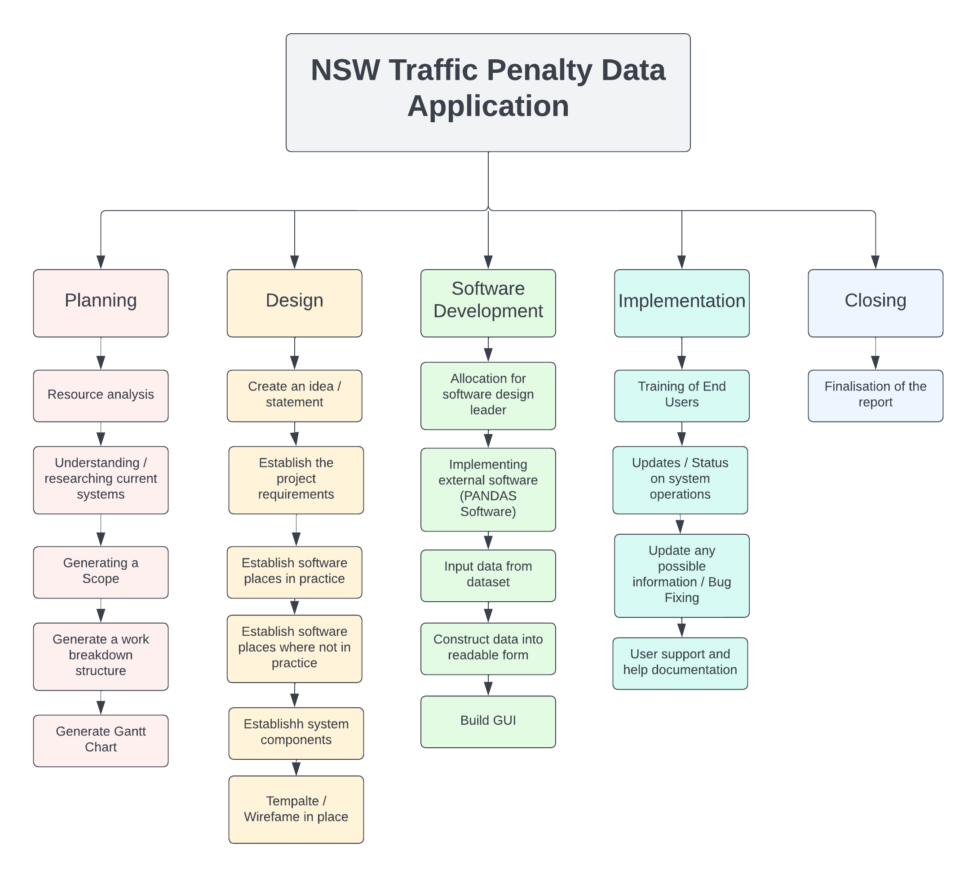

# Activity Definition & Estimation

|  |  |  |
| --- | --- | --- |
| **Activity** | **Definition** | **Time Estimation** |
| **Stage 1 - Planning** |  | This section will take approximately 1 to 9 periods. |
| Resource Analysis | Research of what resources are available or what may be useful in creation of the software. | This activity will take approximately from periods 1 to 9. |
| Understanding / researching current systems | Understanding what current systems do and efficient ways and how using these can aid the progression of this project. | This activity will take approximately from periods 1 to 2. |
| Generating a scope | This activity includes generating a brief detailed statement that outlines the projects direction and what it aims to achieve. | This activity will take approximately from periods 1 to 2. |
| Generate a work breakdown structure | This activity a WBS (work breakdown structure) is a structure used to separate an entire project into smaller parts allowing for tasks to be divided amongst a group. | This activity will take approximately from periods 1 to 7. |
| Generate a Gantt Chart | The activity of a Gantt Chart is what is used for time management purposes it allows for the project manager to keep on top of the group and individuals tasks. | This activity will take approximately from periods 1 to 9. |
| **Stage 2 – Design** |  | This section will continue on from previous end date and take place from approximately 10 to 20periods |
| Create an idea / statement | This activity focuses on heavily creating a plan / idea for the direction the software will head in. | This activity will take approximately from periods 12 to 14. |
| Establish the project requirements | The activity of project requirements is essential in working out the core components needed for the project to succeed. | This activity will take approximately from periods 13 to 15. |
| Establish software places in practice | This activity works out where the software will be in practice and how it could be used in different cases | This activity will take approximately from periods 13 to 16. |
| Establish software places where not in practice | This activity works out where the software will not be used and why it wouldn’t be effective in certain areas. | This activity will take approximately from periods 13 to 16. |
| Establish system components | The system components need to be clearly outlined at this point and implementing them should take effect in the next few stages of development. | This activity will take approximately from periods 15 to 18. |
| Template / Wireframe | Having a design or wireframe to look on will help with the creation of the software. It may not be final but will be a good building point for what the user needs. | This activity will take approximately from periods 16 to 20. |
| **Stage 3 – Software Development** |  | This section will continue on from previous end date and take place from approximately 20 to 31 periods |
| Allocation for software design leader | This section is where the lead of development determines what needs to be developed first and in what order. Also where to developer starts coding the software. | This activity will take approximately from periods 20 to 30. |
| Implementing external software (PANDAS Software) | This activity is where external software is integrated into the project to allow for the software to be further expanded and developed. | This activity will take approximately from periods 20 to 30. |
| Input data from dataset | This activity builds from the external software and process data into the system designed. | This activity will take approximately from periods 22 to 26. |
| Construct data into readable form | This activity is where the software is being constructed and is at a point where testing is underway, and the complete program is almost in place. | This activity will take approximately from periods 23 to 39. |
| Build GUI | This activity is where the graphical unit interface comes into play where visual design elements will come into place with the software developed. | This activity will take approximately from periods 23 to 31. |
| **Stage 4 – Implementation** |  | This section will continue on from previous end date and take place from approximately 31 to 38 periods |
| Training of end users | This activity will include how the users are interacting with the software and if the GUI needs any preference changes etc. | This activity will take approximately from periods 31 to 34. |
| Updates / Status on system operations | This is where after testing and training if there need to be any changes or anything that wasn’t functioning properly is noted. | This activity will take approximately from periods 32 to 34. |
| Update any possible information / Bug fixing | This activity is where bug fixing takes place, changing or implementing new systems to overcome the errors are done here. | This activity will take approximately from periods 33 to 35. |
| User support and help documentation | Producing documentation so that users can understand the GUI and software are important for the users and their understanding. | This activity will take approximately from periods 33 to 38. |
| **Part 5 – Closing** |  | This section will continue on from previous end date and take place from approximately 37 to 42 periods |
| Finalising of the Report | This activity is where:   * What happened during the project * How can things be improved in general * What error was the biggest issue * Final documentation submitted to the director. | This activity will take approximately from periods 37 to 42. |

# Gantt Chart

